Install SQL Server 2019 Developer Edition

To install SQL Server 2019, you need to download it from [SQL Server Downloads | Microsoft](https://www.microsoft.com/en-us/sql-server/sql-server-downloads)

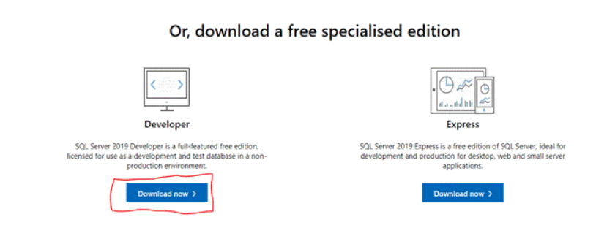

Click the "Download" button for downloading the SQL Server 2019 executable file.

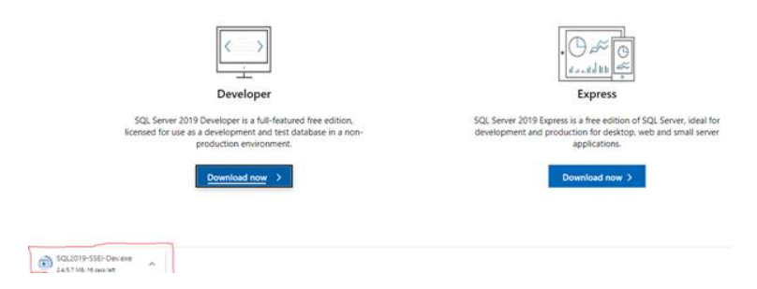

1. **Install Database Engine, SSAS and SSIS.**

**Step1**, open your systems download path and find the .exe file. SQL2019-SSEI-Dev.exe

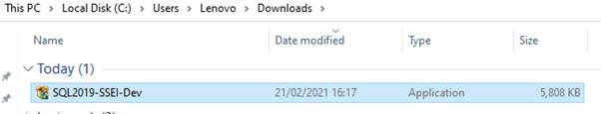

Double-click the exe file SQL2019-SSEI-Dev.exe to start installing.

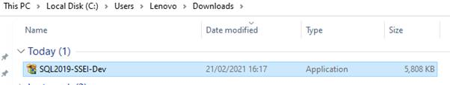

After double clicking, the system will ask the permission: “Do you want to allow the following to make a change this computer? Click yes to continue installing the SQL Server 2019. Or Click “Yes” on any security prompt.

**Step 2**, the installer asks you to select the installation type, choose the Custom installation type.

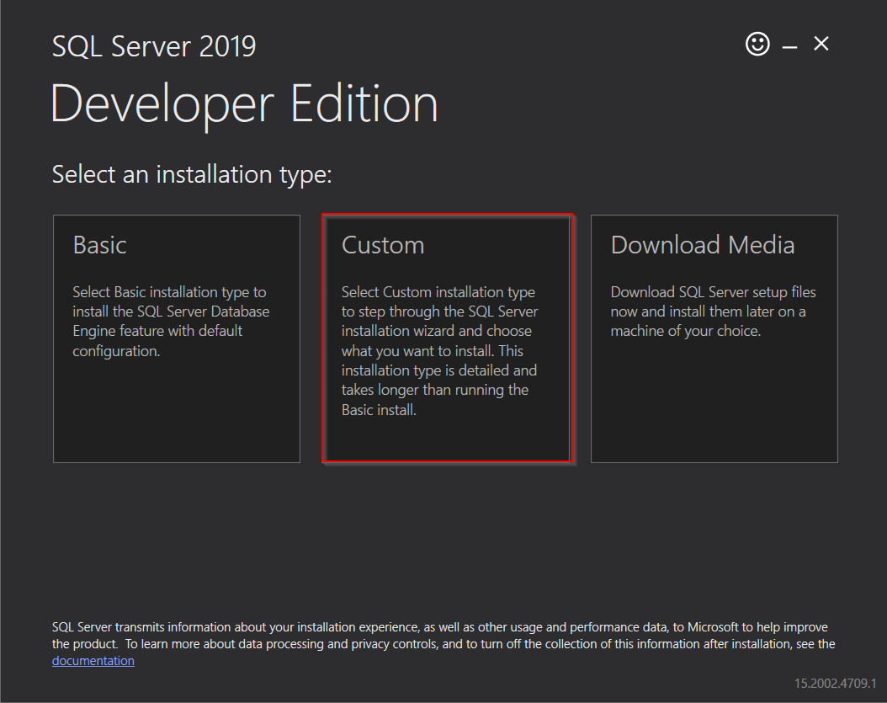

**Step 3,** select a media location, click “Install” button.

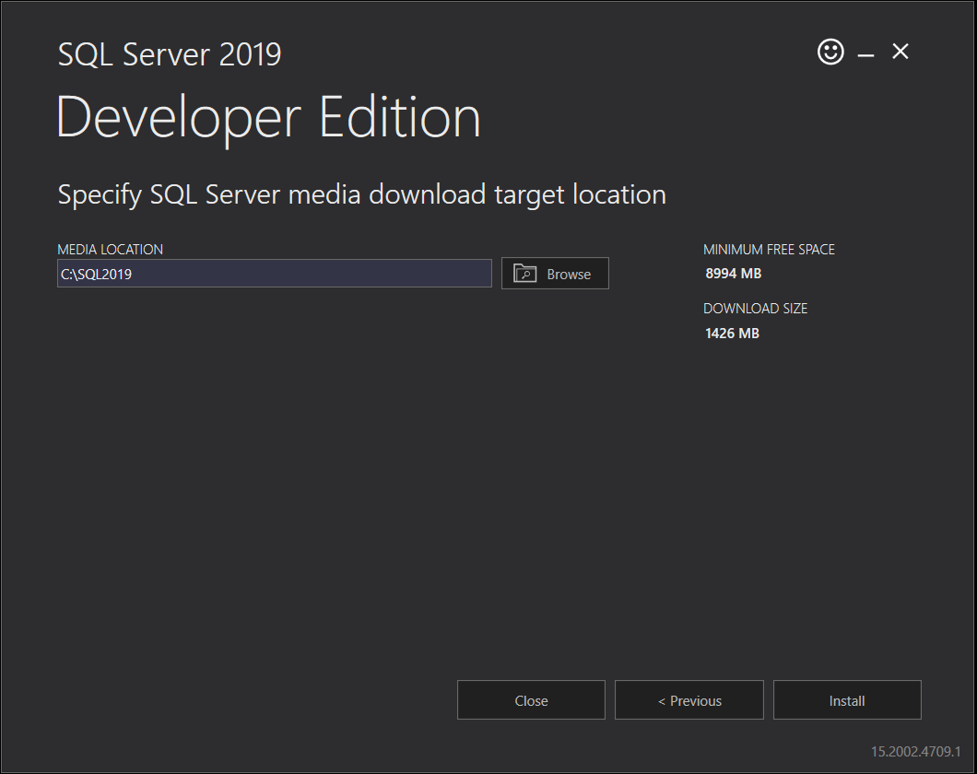

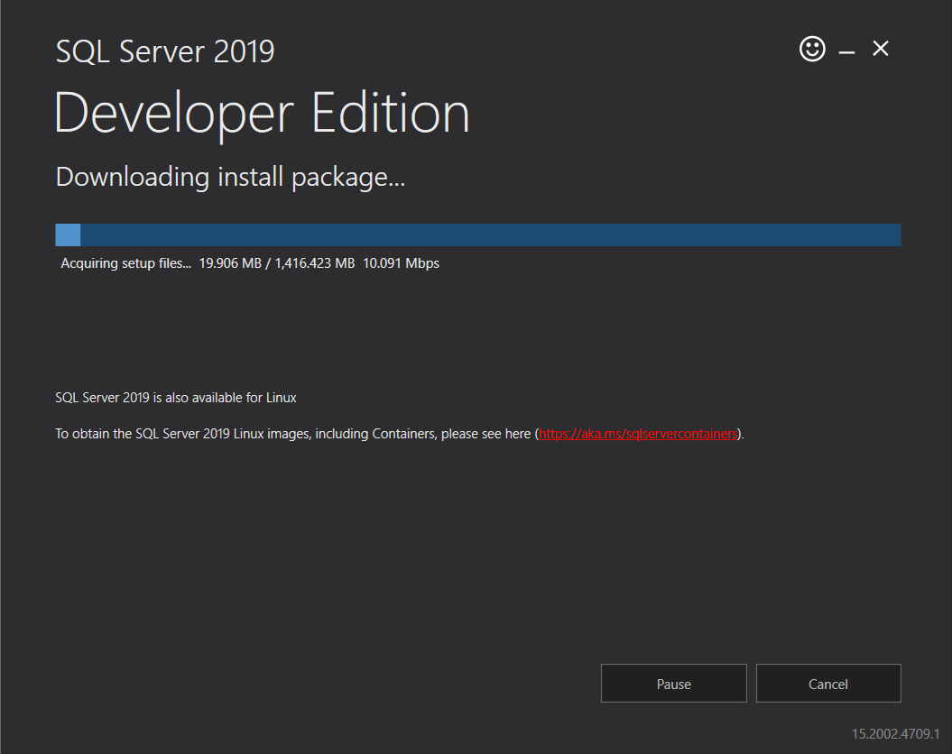

**Step 4,** as shown below, click “Installation” from left side then “New SQL Server stand-alone installation” from right side.

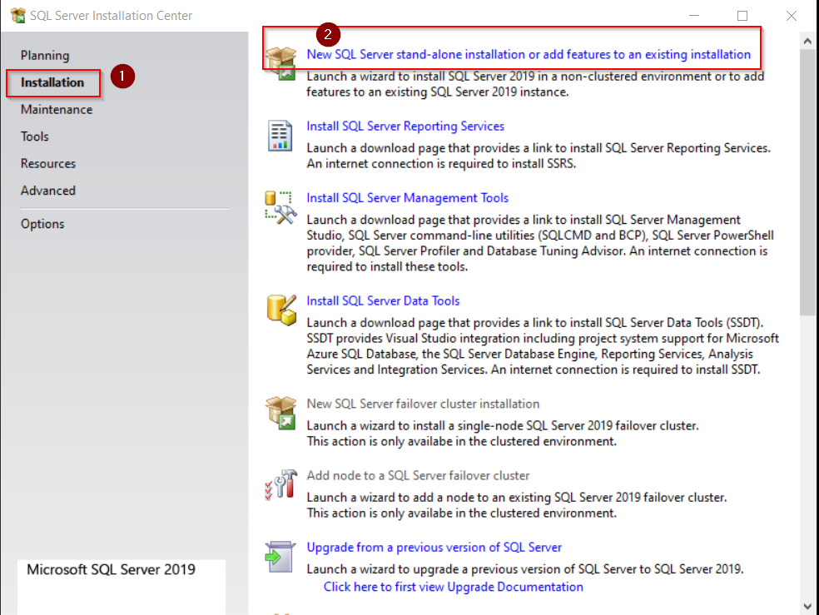

**Step 5,** select “Developer” and click “Next”.

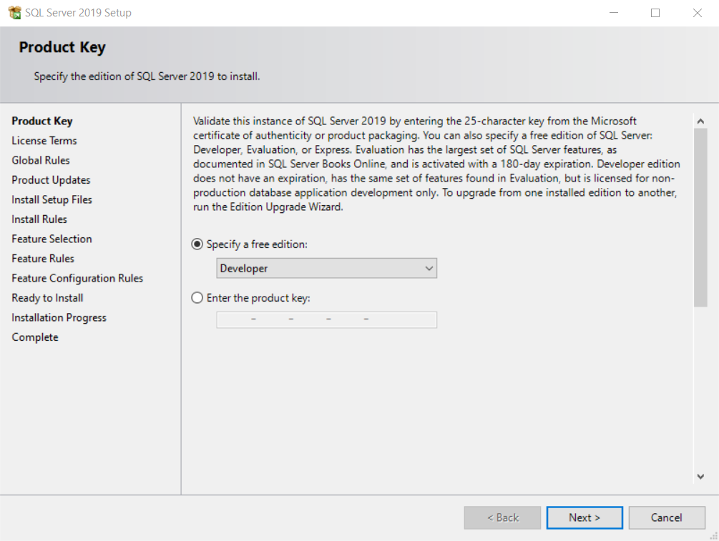

**Step 6,** tick “I accept the license terms” then click “Next”.

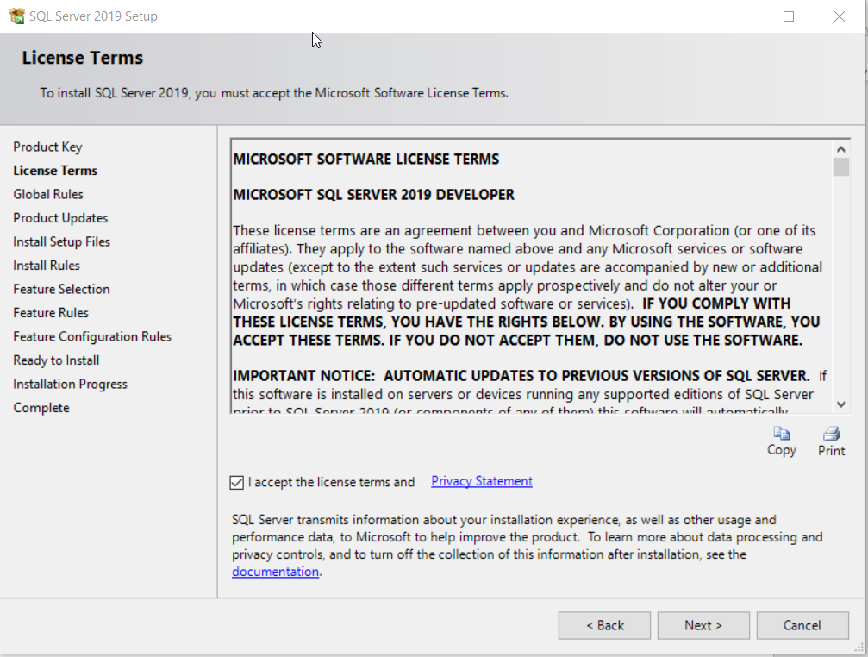

Click “Next”

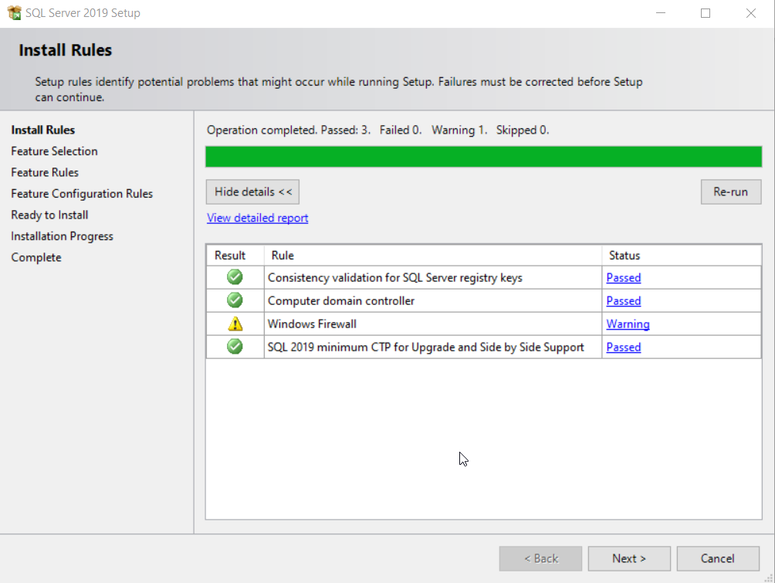

**Step 7,** select “Database Engine Services”, “Analysis Services” and “Integration Services” from list, change install directory or location to a different folder if you want to, click “Next”.

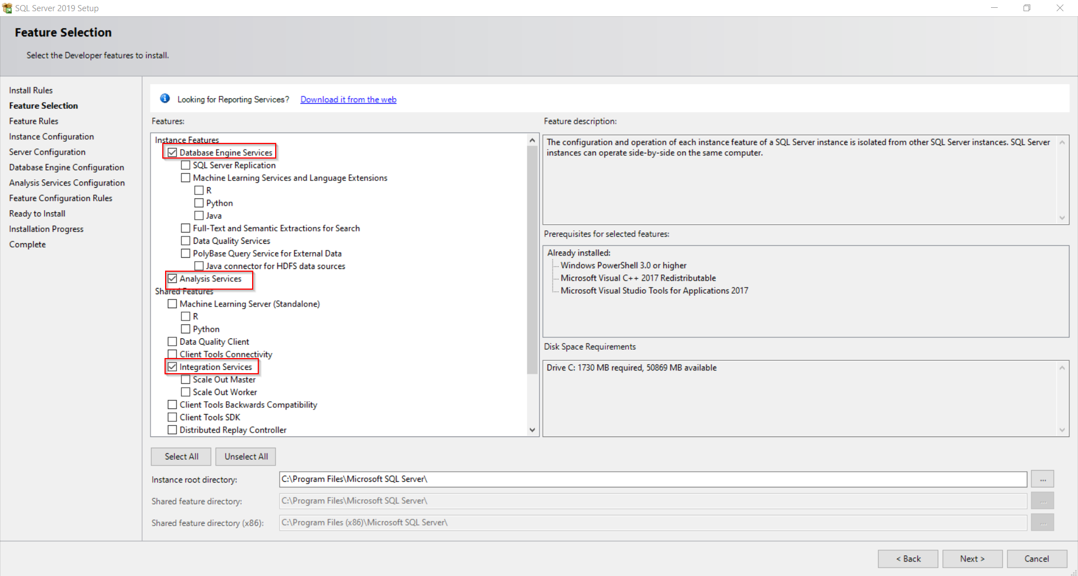

**Step 8,** select Named instance and input “IC” as instance name and ID, click “Next”.

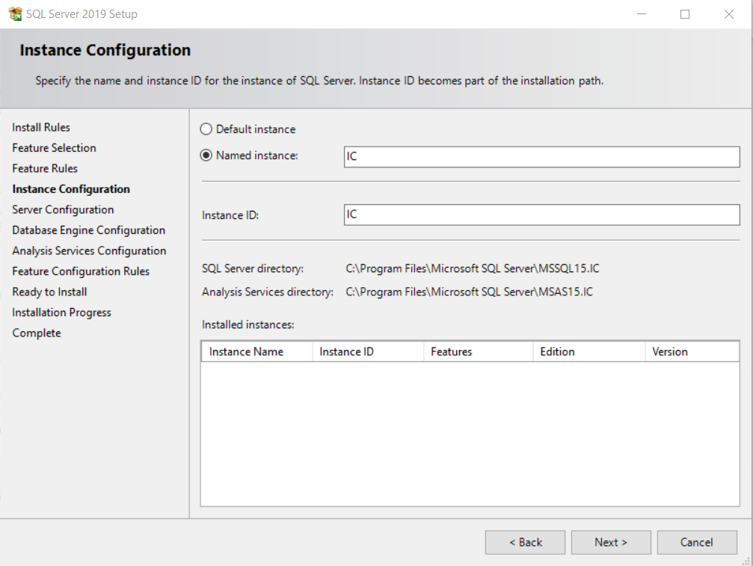

Click “Next”.

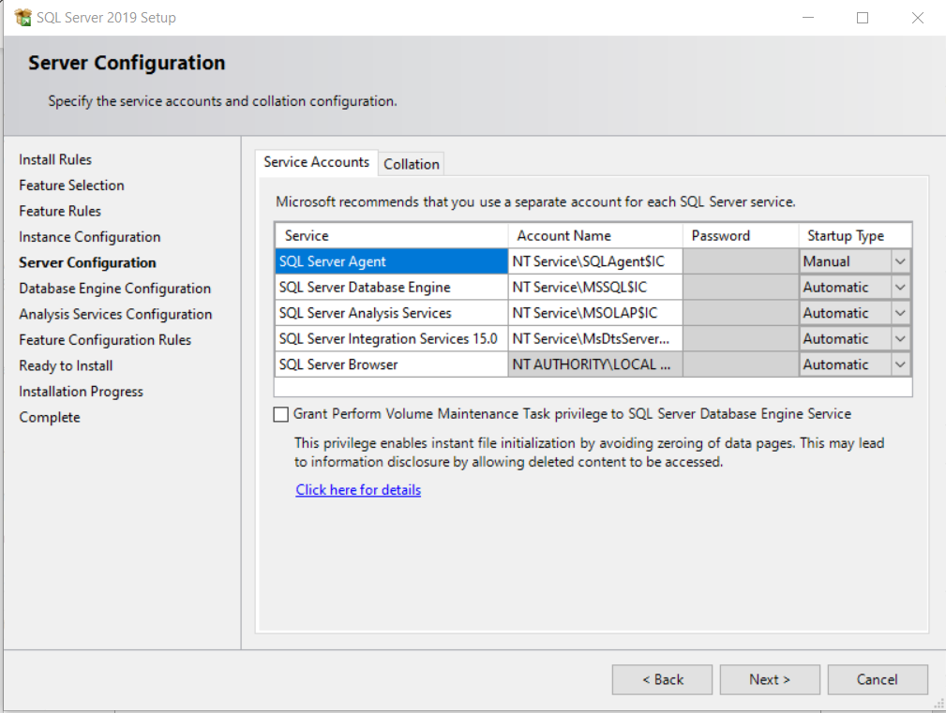

**Step 9,** select “Mixed Mode” authentication and input your password, click “Add Current User”, then click “Next”.

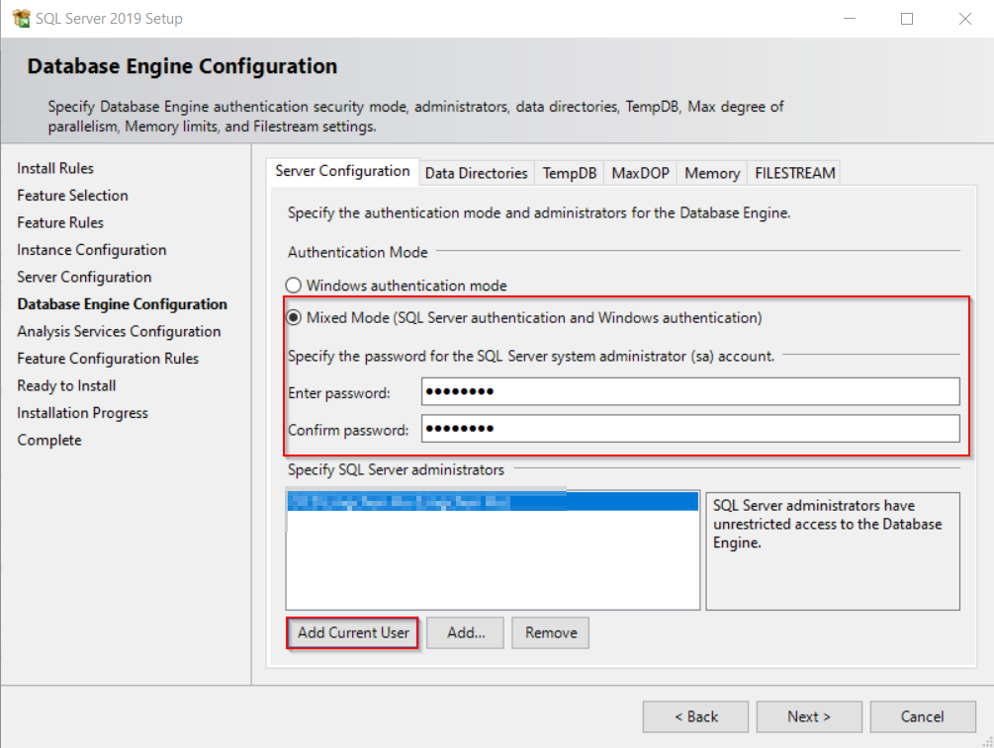

**Step 10,** select “Tabular Mode” and click “Add Current User” button then click “Next”.

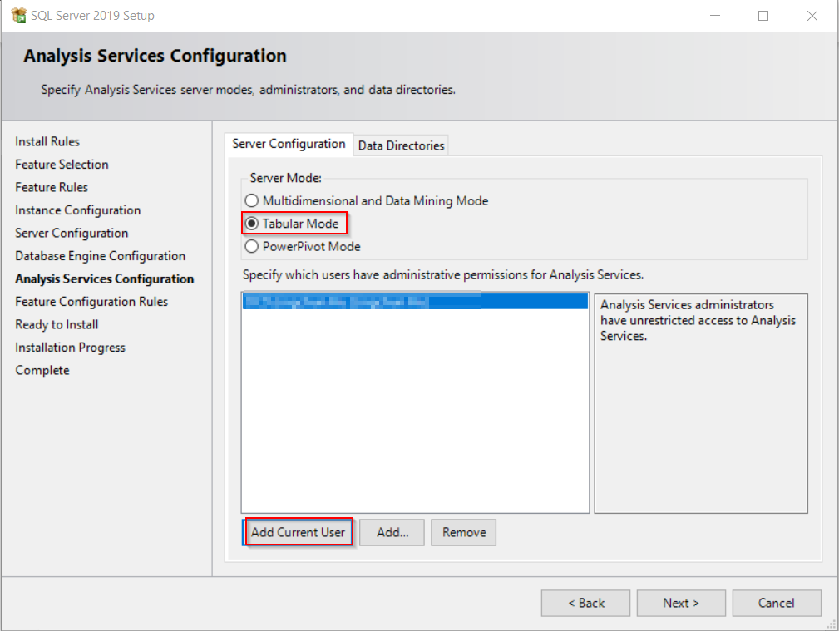

**Step 11,** click “Install” and wait until it finishes.

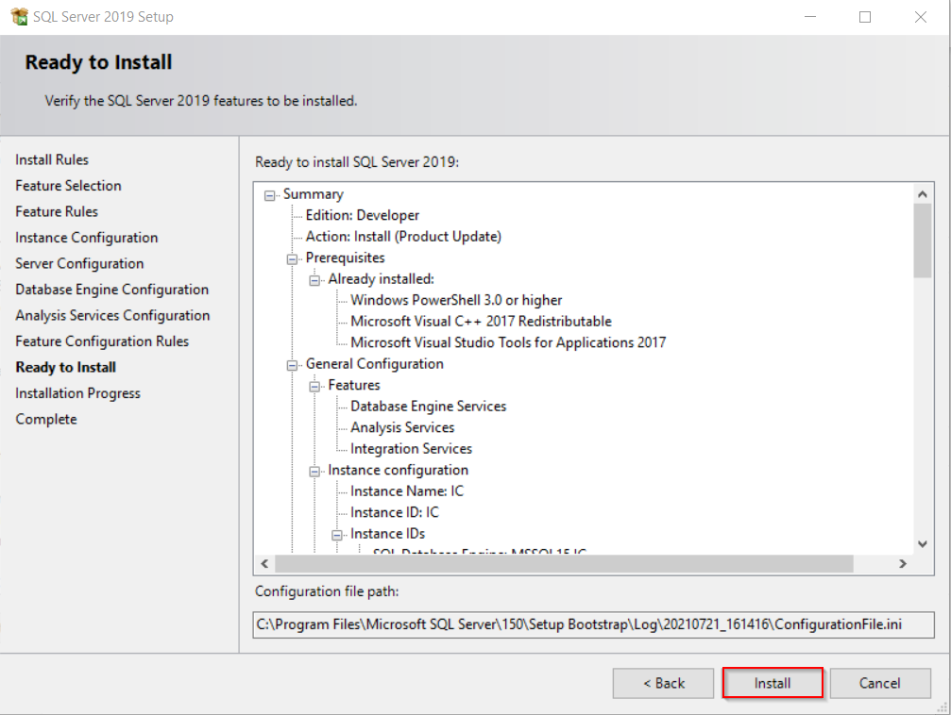

**2. Install additional SSAS Multi-dimensional cube mode.**

Please repeat above step 1 to step 6 again, when come to step 7, select “Analysis Services” only and click “Next”

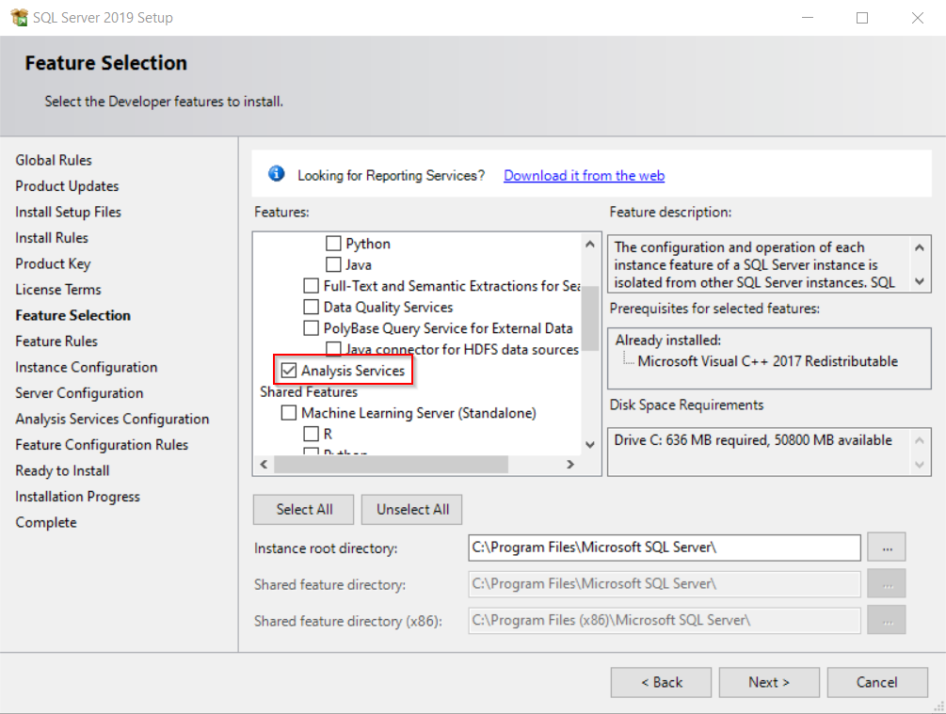

Type “CUBE” as Named instance and Instance ID, click “Next”.

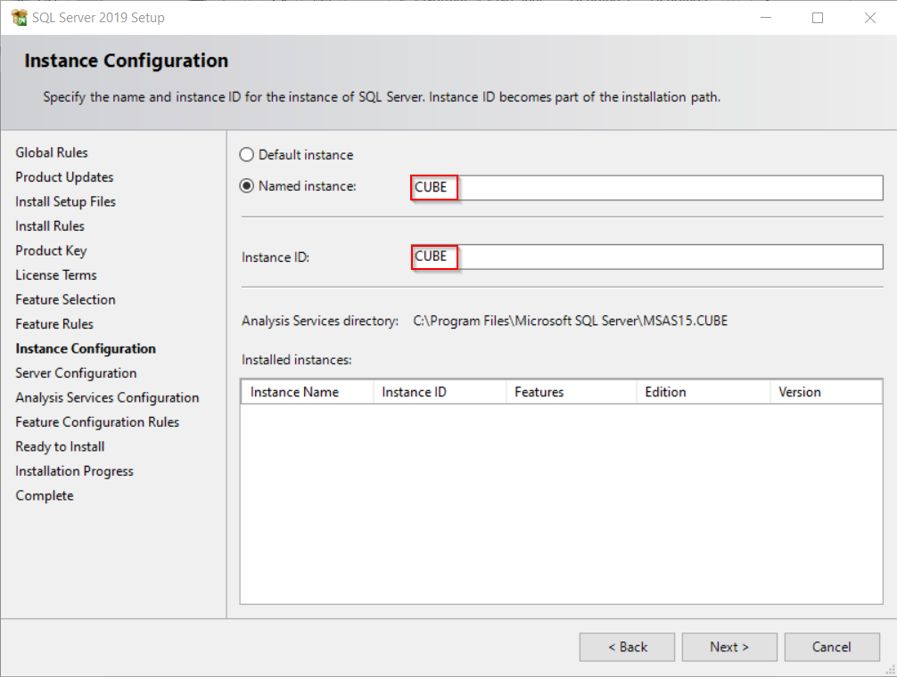

Click “Next”.

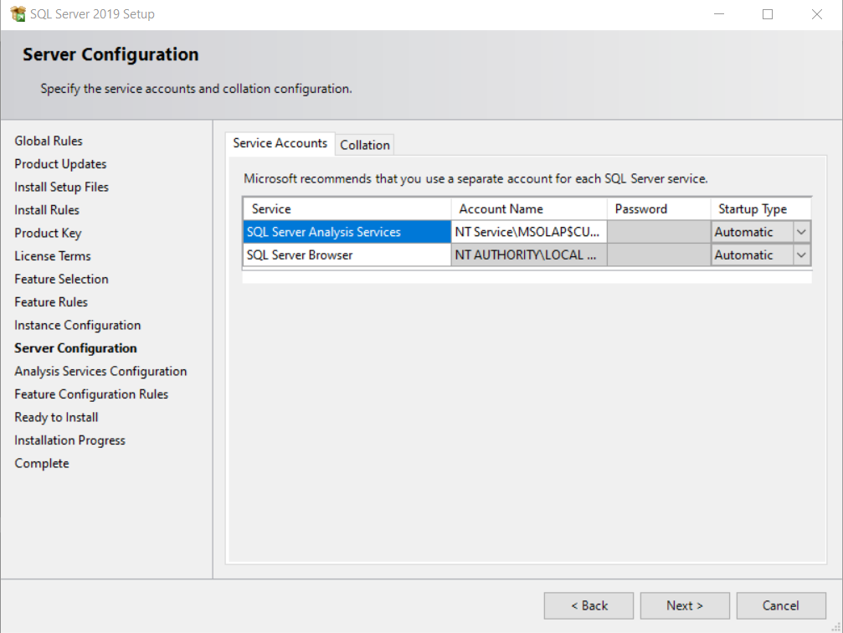

Select “Multidimensional and Data Mining Mode”, click “Add Current User” and click “Next”.

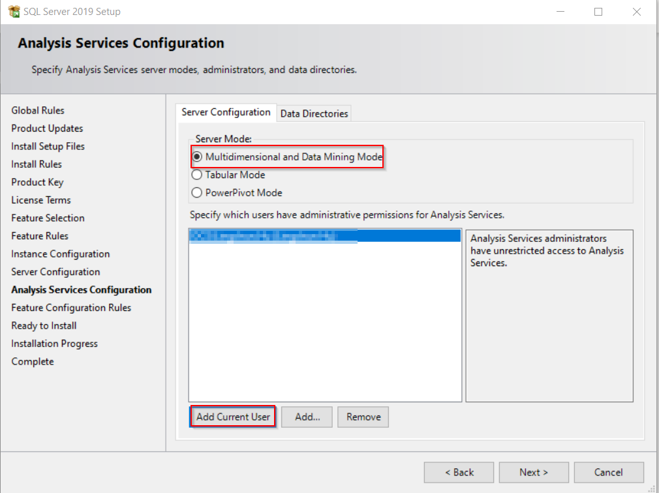

click “Install” and wait until it finishes.

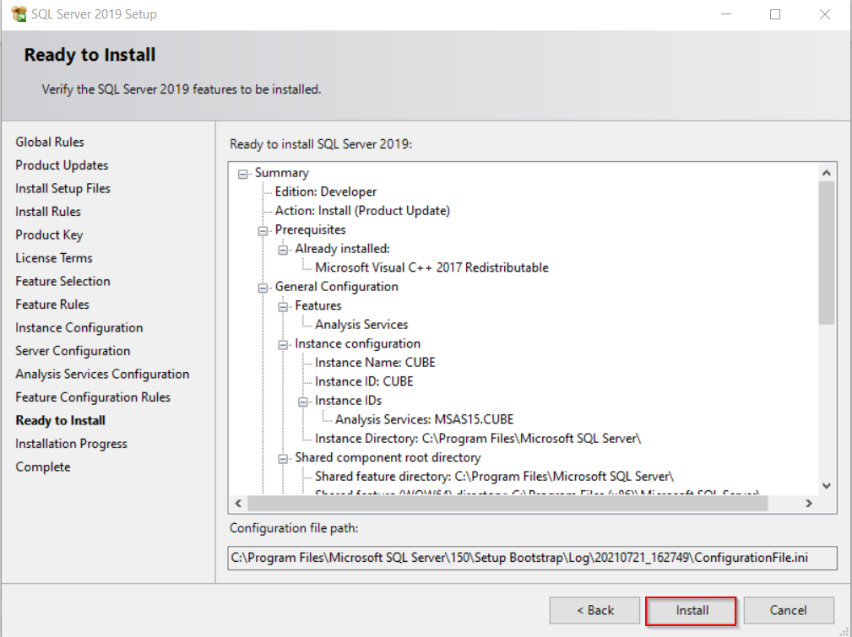

**3. Install SSRS.**

Download SQL Server Reporting Service

[Download Microsoft SQL Server 2019 Reporting Services from Official Microsoft Download Center](https://www.microsoft.com/en-us/download/details.aspx?id=100122)

1. Find downloaded SQLServerReportingServices.exe and launch the installer.
2. Select **Install Reporting Services**.

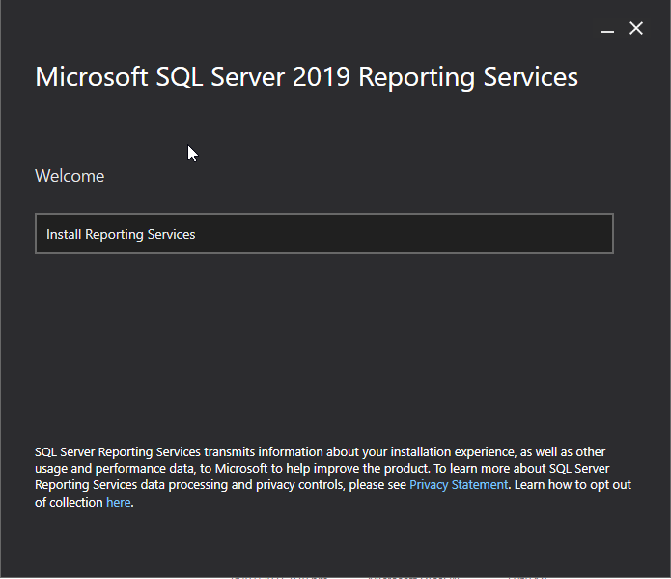

1. Choose an edition to install and then select **Next**.

For a free edition, choose Developer from the drop down.

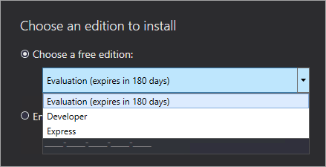

1. Read and agree to the license terms and conditions and then select **Next**.

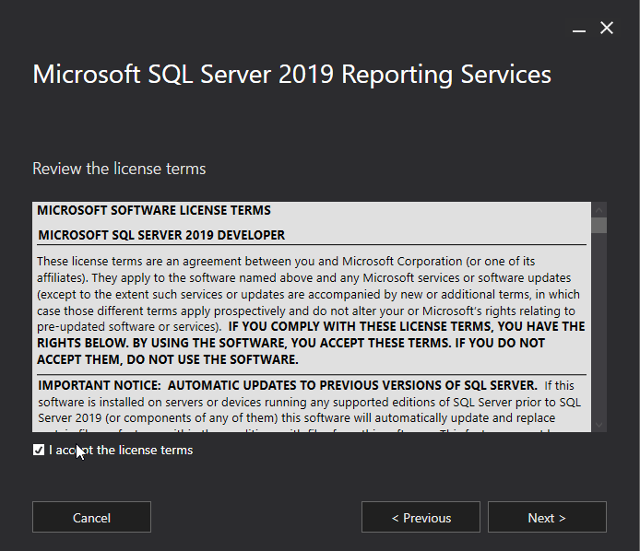

1. Select **Next** to install the report server only.

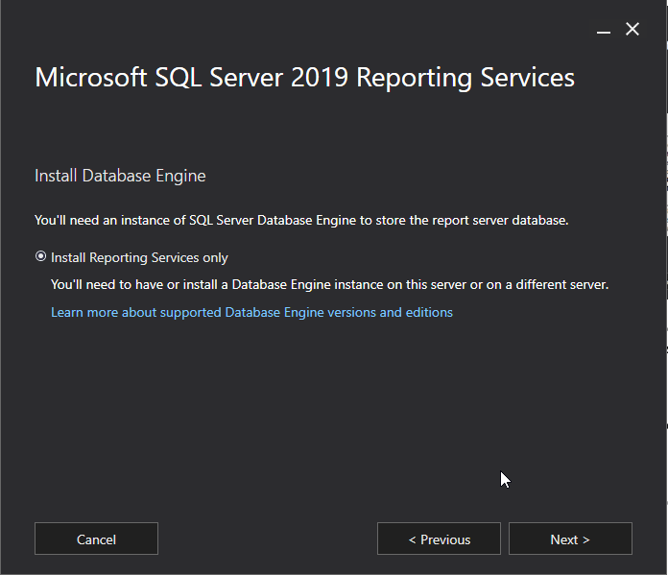

1. Specify the install location for the report server. Select **Install** to continue.

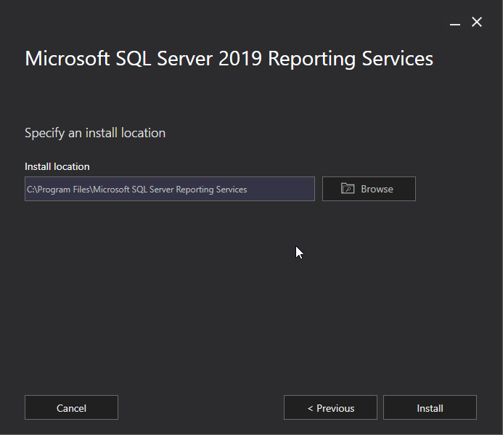

1. After a successful setup, select **Configure Report Server** to launch the Report Server Configuration Manager.

#### **Configure Server**

At this point Reporting Services is installed and it's time to do some basic configuration to it before we can do anything.

Select 'Configure report server' to open the Configuration Manager.

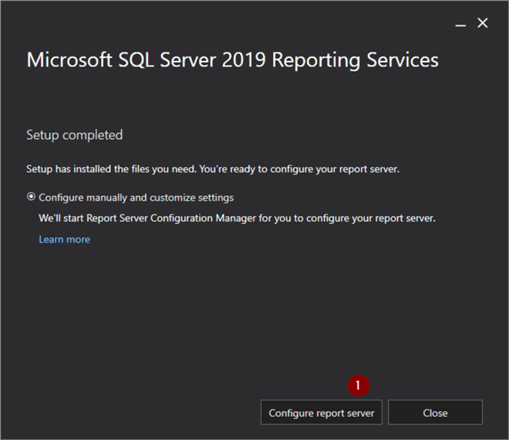

#### **Configuration Manager**

Reporting Services Configuration Manager program opens, and we will see the machine name and instance will automatically populate. The first step is to connect to the SSRS server.

1. Connect

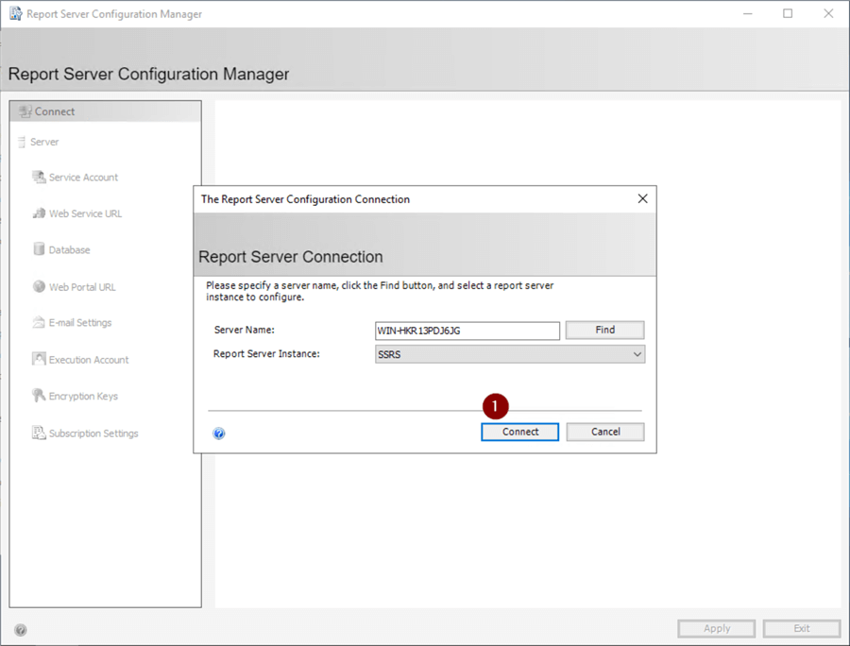

#### **Service Account**

Best practice is to not use the default account to run any of the SQL Server services. This discussion is somewhat out of scope for this tip but Microsoft Docs has more information on configuring Windows service accounts for SQL Server here: [Configure Windows Service Accounts and Permissions](https://docs.microsoft.com/en-us/sql/database-engine/configure-windows/configure-windows-service-accounts-and-permissions?redirectedfrom=MSDN&view=sql-server-ver15)

1. 'Service Account'
2. Configure service account.
3. Apply

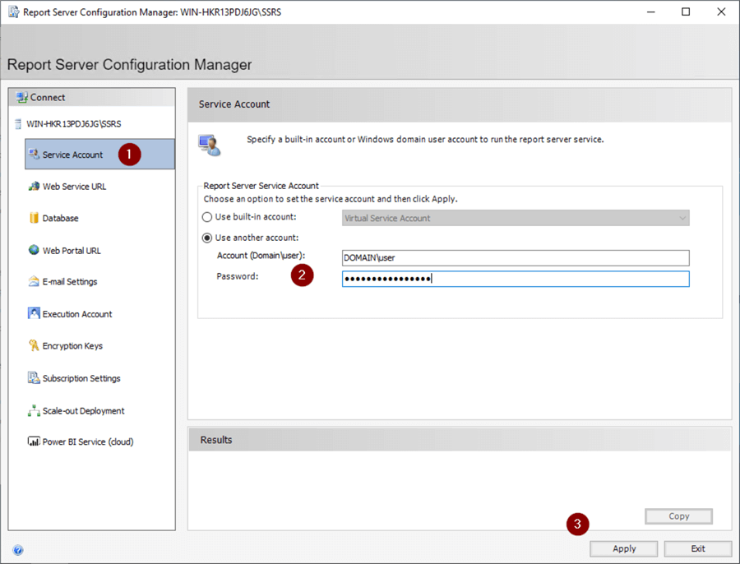

#### **Report Server Databases**

The Report Server Database screen is where we create the databases ReportServer and ReportServerTempDB.

1. Database
2. 'Change Database'

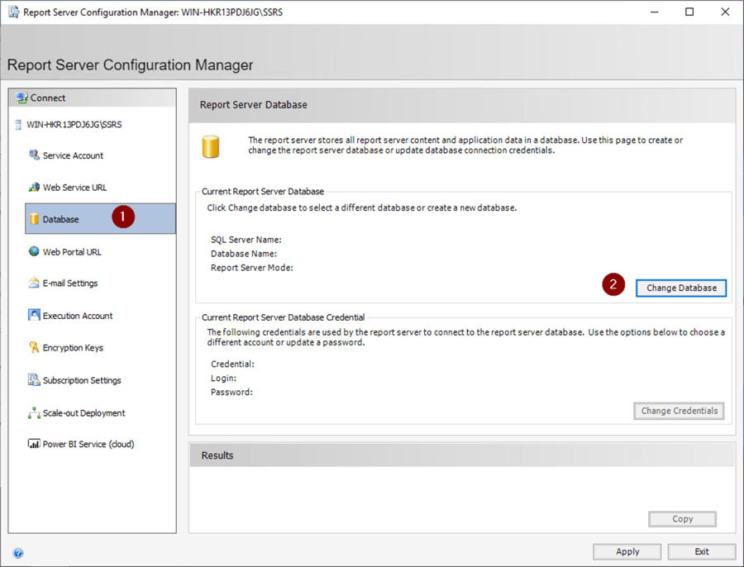

#### **SSRS Databases**

We are creating a fresh installation of SSRS, so we leave the 'Create a new report server database.' radio button selected.

1. Next

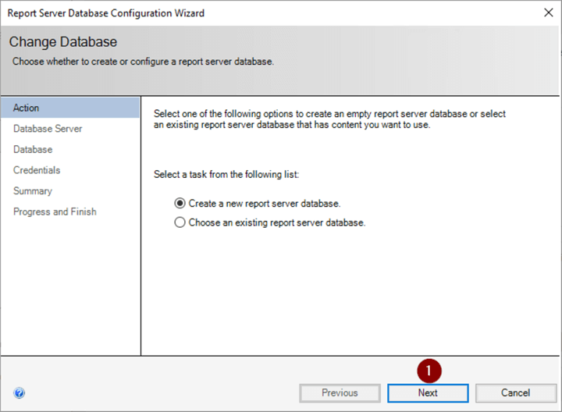

#### **Verify Connectivity to SQL Server**

It's a good idea to verify that we can successfully connect to the SQL Server with our credentials here before attempting the database creations.

1. 'Test connection'
2. OK
3. Next

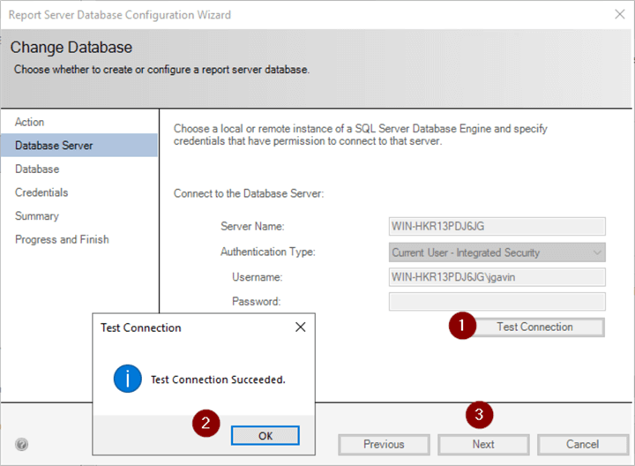

Continue if Test Connection was successful.

1. Next

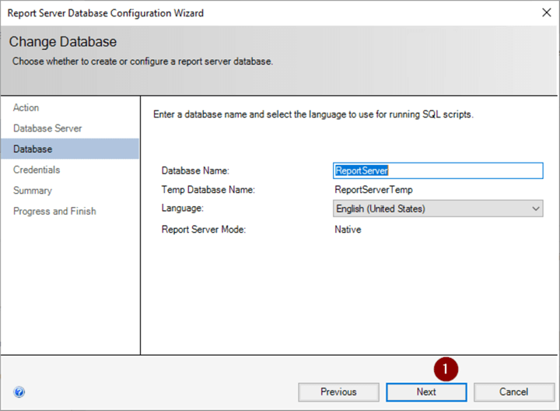

1. Next

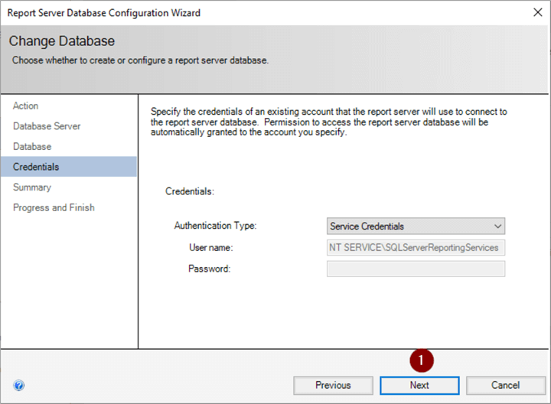

#### **Create Databases**

We can now verify our information is correct before proceeding with the database creations.

1. Review Summary
2. Next

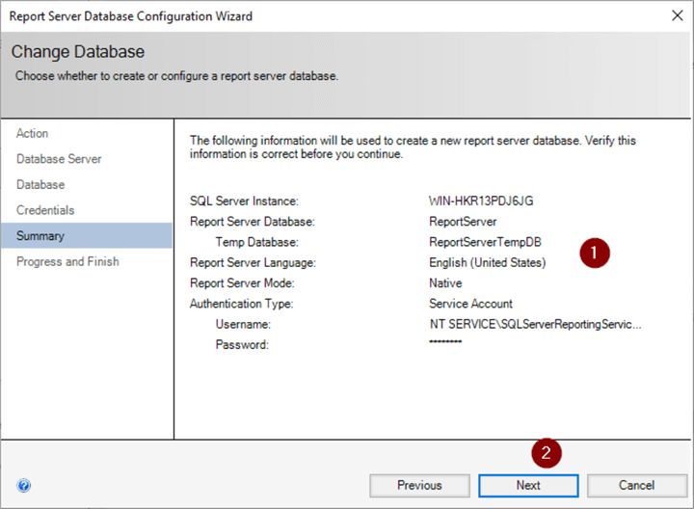

#### **Verify Successful Completion**

We want to see that each step was successful.

1. Verify all steps show Success
2. Finish

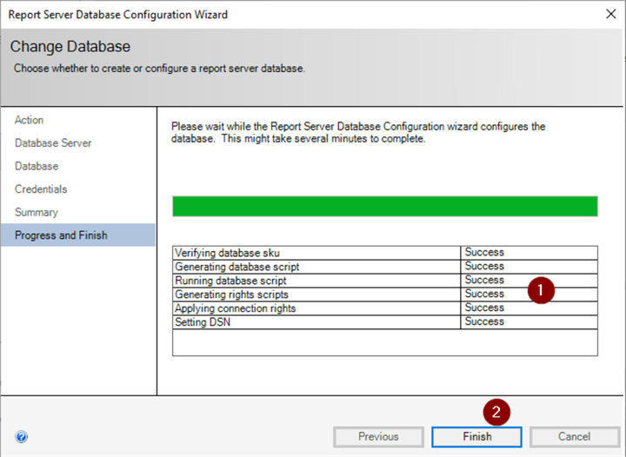

#### **Create URLs**

Now that we have our databases created it's time to create the SSRS web service. First, we create the Web Service URL.

1. 'Web Service URL'
2. Apply

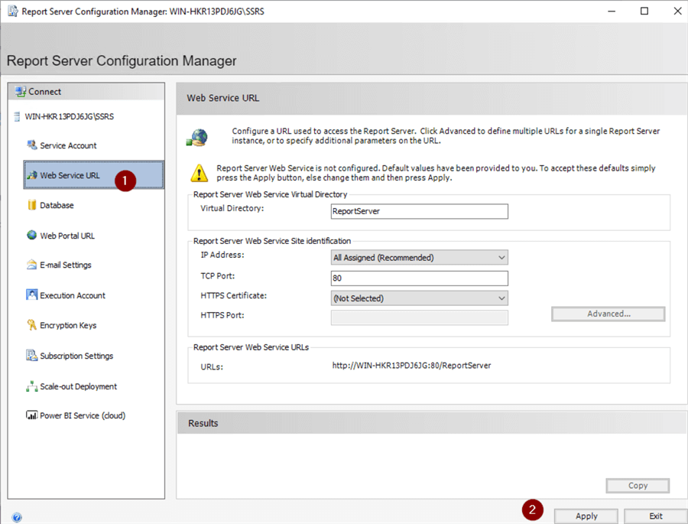

Next, we create the Web Portal URL.

1. Web Portal URL
2. Apply

Then SSRS will restart.

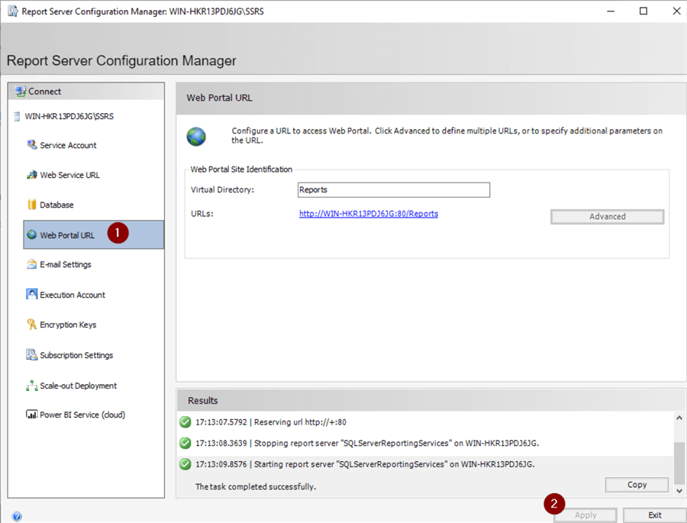

#### **Very URL Creation**

Time to verify we can connect to both URLs.

1. Click 'Web Service URL'
2. Click on URL

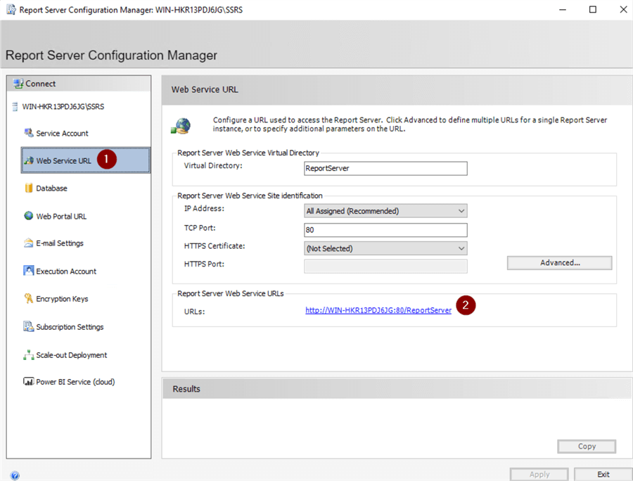

We expect to see the default browser open to Report Server screen.

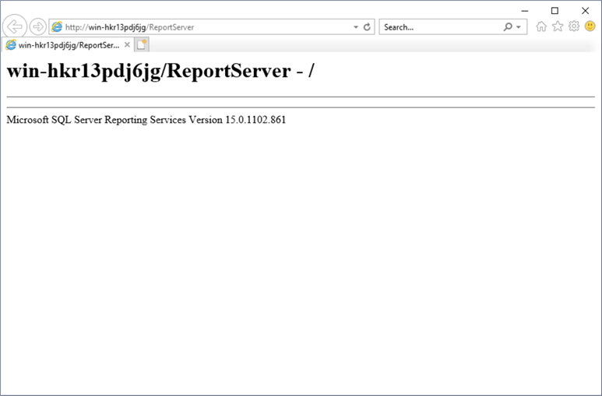

Now, we'll check the Web Portal URL.

1. 'Web Portal URL'
2. Click on URL

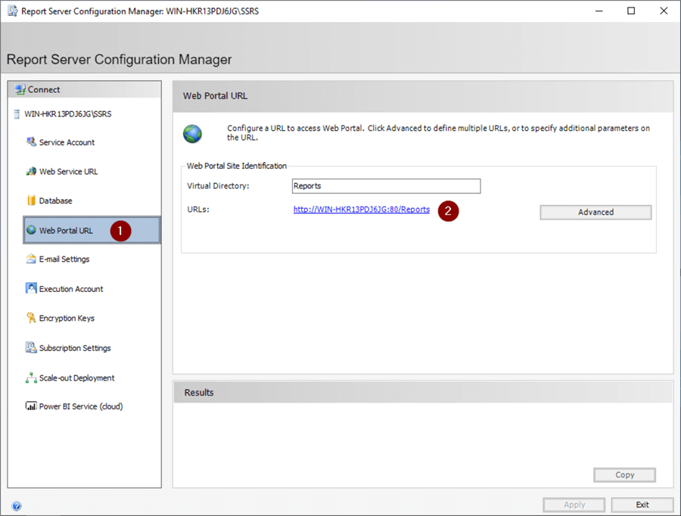

We expect to see the default browser open to the Reporting Services Screen.

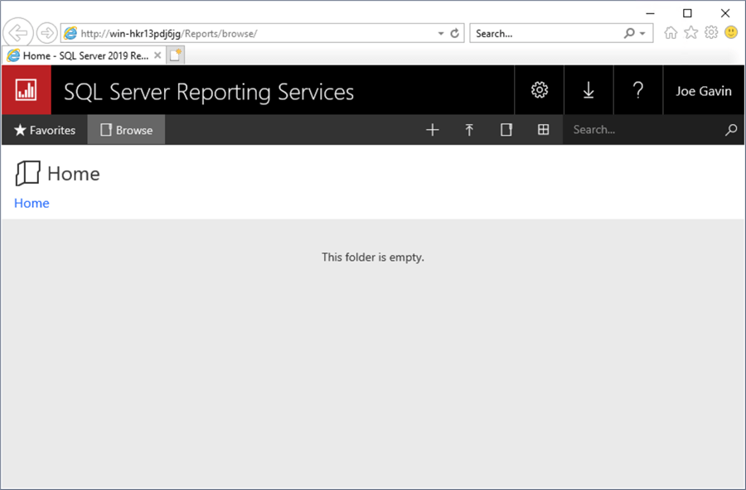

We now have a fully functional SSRS installation that is ready to deploy reports to. Following are some optional settings we can also configure.

#### **Close Configuration Manager**

1. Exit

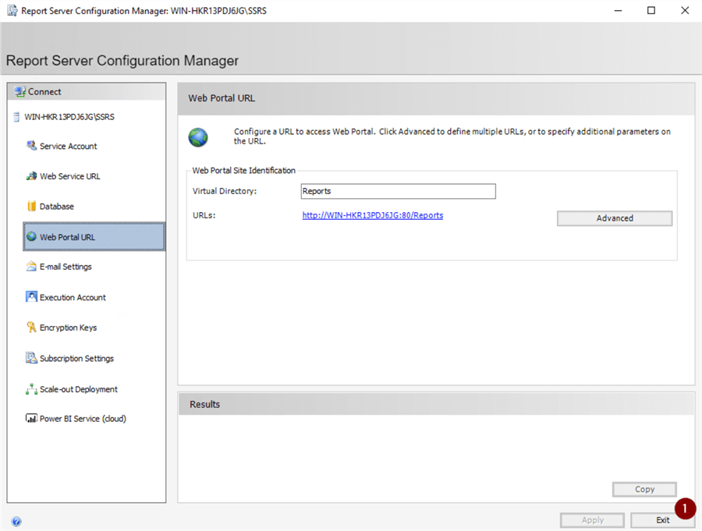

**4. Install SSMS.**

Download and install SQL Server Management Studio

[Download SQL Server Management Studio (SSMS) - SQL Server Management Studio (SSMS) | Microsoft Docs](https://docs.microsoft.com/en-us/sql/ssms/download-sql-server-management-studio-ssms?view=sql-server-ver15)

Click the "Download" button for downloading the SSMS 2019 executable file on the downloaded path.

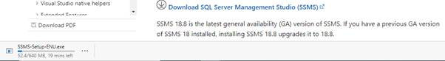

Open your systems download path and find the .exe file. SSMS-Setup-ENU.exe

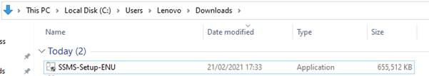

Double-click the exe file SSMS-Setup-ENU.exe to starting installing. The installation process of SMSS is straightforward which you just need to follow the screen sequence.



After double clicking, the system will ask the permission: “Do you want to allow the following to make a change on this computer? Click yes to continue installing the SQL Server Management Studio 2019. Or Click “Yes” on any security prompt."

Installation window will be open after giving permission to install. Click the Install button.

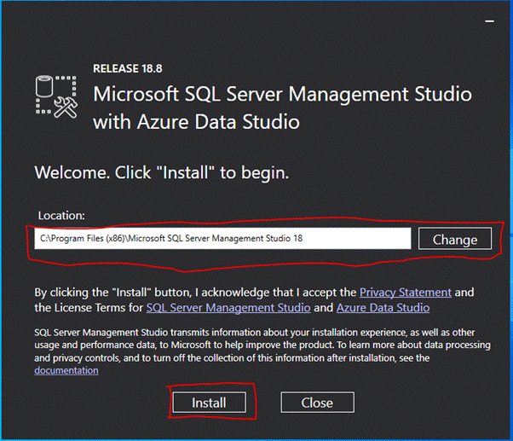

After loading packages progress bar will be shown. One is Package Progress and Overall Progress. Wait for few minutes while the installer sets up the software.

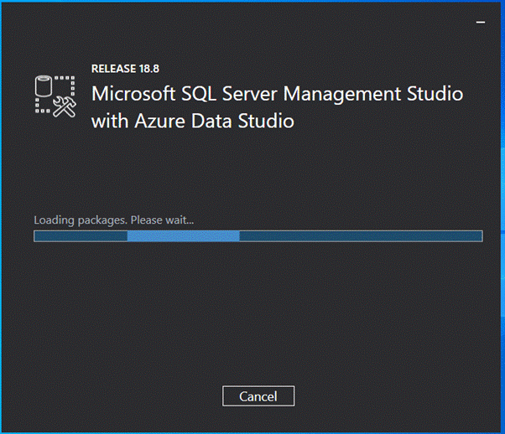

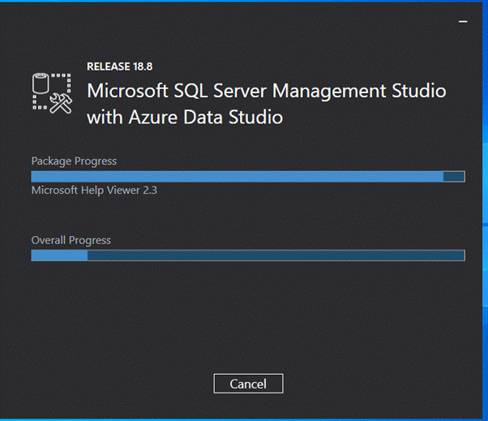

Installation completed. After completing the installation restart your computer for complete setup.

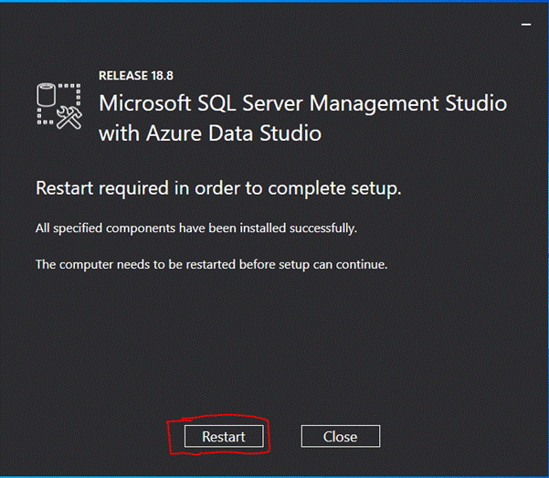

Go to all programs in your systems, we can see two folders, one is Microsoft SQL Server 2019 and another one is Microsoft SQL Server Tool 2018. Under Microsoft SQL Server Tools 18 you can see the Microsoft SQL Server Management Studio 18.

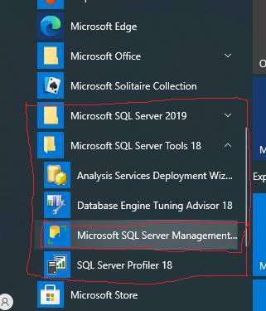

Double-click on SQL Server Management Studio 18 and it will open looks like below screenshot. The first opening will take a few minutes.

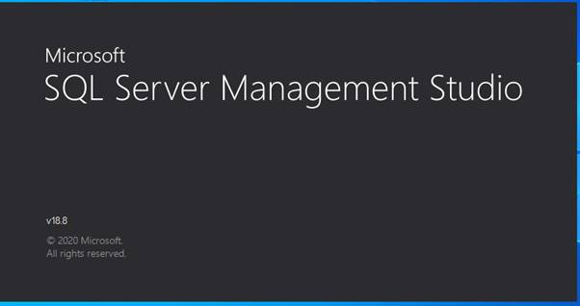

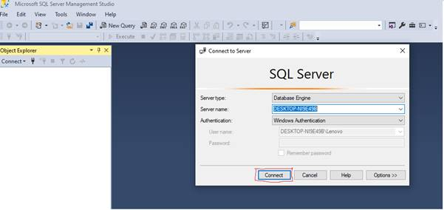

After opening SQL Server Management Studio 2018, we can see it looks like the below screenshot.